13 December 2018

Andrew Goodall
Director General - Health and Social Services, NHS Wales
Welsh Government
Cathays Park
Cardiff
CF10 3NQ
Nicholson House
Lime Kiln Close
Stoke Gifford
BRISTOL BS34 8SR
Telephone 0117 931 7137

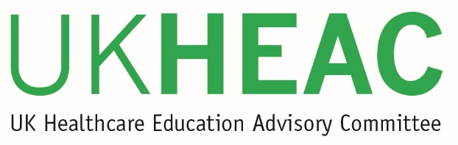
Dear Andrew

UK Healthcare Education Advisory Committee update

The UK Healthcare Education Advisory Committee (UKHEAC) met on 21 November 2018. This letter summarises key items of discussion and feedback arising from that meeting for the benefit of system leaders in healthcare education. A similar letter is being sent to appropriate policy bodies in each of the UK nations.

Following a presentation to the Committee on the Research Excellence Framework (REF) by John Iredale (Chair of Main Panel A: Medicine, health and life sciences) members discussed the benefits and drawbacks of the outlined approach and measures arising from the Stern review. The Committee raised a concern on the visibility of health professions and the particular challenges for academic careers in the smaller allied health professions and challenged how the REF might be able to support these. Members also recommended that it was important to ensure the proposed large panel for allied health has sufficient expertise in order to be able to assess a disparate breadth of professions.

The Committee received a presentation on the development of UK Research and Innovation (UKRI) and the current priorities for research from Research England. Members discussed the importance of a joined up approach between teaching and research and recommended that care needs to be taken if there are any future changes to teaching funding to ensure that it does not place undue burden on provider budgets that could adversely impact delivery of research.

Members discussed recruitment across the UK. Although it is still a little early in the 2018-19 recruitment cycle to be able to draw upon validated data, it was noted that previously identified challenges in recruitment to Learning Disability Nursing, Podiatry, Therapeutic Radiography and other specialist Allied Health subjects remain. For England, whilst the focus of the current “deep dive” on undergraduate nursing by the DHSC was welcomed, it was felt that that the challenges facing allied health provision also needs to be considered. It was recognised that the concerns and challenges facing each profession may require different solutions, with consideration needing to be given to geography as well as subject matter.

Concern was expressed by members over the availability and capacity to increase clinical placements in order to deliver any meaningful growth of students in NMAH professions. It is also important to maintain the quality of such placements to ensure that students receive a positive experience, recognising the increasing challenges for trusts who need to meet a range of different curriculum needs, for different types of student learners, across different disciplines.

For medical recruitment, overall application rates appear strong but the Committee noted some concern over the 8% drop in applications from EU students which is likely a result of Brexit uncertainty. Members also highlighted the current lack of clarity regarding the arrangements and fees for international students in England from 2020-21 and recommended that the DHSC clarify the situation as soon as possible.

The Committee received an update on the Teaching Excellence Framework (TEF) from the Office for Students, noting the development of the new assessment model and the current testing and refinements taking place. Key points of interest to the UKHEAC are how small subjects with limited data may be recognised within the TEF, and how regulated professional qualifications might be represented in any TEF score. Members particularly highlighted the importance of avoiding unintended consequences which could negatively impact on vulnerable subject provision.

A review of the UKHEAC was carried out by the four UK funding bodies with input from the Committee over summer and autumn 2018 to ensure the Committee remains effective and relevant. This review has led to suggested new terms of reference, revisions to the balance and makeup of the membership, and several recommendations to improve communications and working practice of our members. The review outcomes (assuming final approval from the UK funding bodies) are expected to take effect from March 2019, with the first meeting of the new format UKHEAC in June 2019. The Committee values close engagement with the Welsh Government, and in setting its priorities for the future we would welcome input from you and your colleagues on how we best we can provide constructive and timely input to support policy development and implementation.

I trust that you find the above points useful in ongoing discussions and that due consideration is given to the issues raised. We will share any response to this letter with our members at the next UKHEAC meeting in March 2019.

Yours sincerely
Professor Dame Jessica Corner
Chair of UKHEAC

cc Alex Howells, Chief Executive of Health Education and Improvement Wales
Chris Jones, Deputy CMO for Wales
David Blaney, Chief Executive of HEFCW

