# Annex A: Bidding template for Equality in Higher Education Innovation Fund

## How to complete the template

The deadline for returning completed bids is **25 October 2024.**

Please email completed templates to [equalityofopportunityinnovation@officeforstudents.org.uk](mailto:equalityofopportunityinnovation@officeforstudents.org.uk). We will confirm receipt. You should also use this inbox for any questions throughout the process, and we will respond as soon as possible.

1. Please use the template provided below – your bid will not be accepted otherwise. Please use the text boxes. These can be expanded to the required length and the explanatory notes in *italics* may be removed to provide more space for your text.
2. All sections and tables must be completed. Please do not amend or otherwise alter the template layout.
3. The word limits are a maximum and we do not expect all responses to reach these upper limits. The completed template should not exceed the word limits for each question. It must be submitted as a Microsoft Word document.
4. To include with the completed template, we also require:
5. Theory of change logic model.
6. Signed letters of support from all partners in the collaboration, including from the accountable officer of the higher education providers involved. These letters of support must clearly state what each partner is contributing towards the project: for example, the activities to be delivered, whether there is cash or investment in-kind to be provided, and the monetary value of the latter; any conditions on these investments; and any issues of timing. The letters should not simply state generic support for the proposal. These letters should ideally be collated into one PDF document and sent alongside the completed bid template.
7. The bid should show how it meets the requirements and criteria set out in paragraphs 38 to 54 of the guidance document.

## Table 1: Contact for lead organisation

|  |  |
| --- | --- |
| **Legal name of lead organisation** |  |
| **Higher Education Provider UK Provider Reference Number (if relevant)** |  |
| **Project start date** |  |
| **Project end date** |  |
| **Approval from accountable officer or head of organisation (for lead provider). Signed letter must be provided.** | *(All bids need confirmation of this approval in order to proceed.)* |

## Table 2: Contact person for the bid

|  |  |
| --- | --- |
| **Title and full name** |  |
| **Role** |  |
| **Telephone number** |  |
| **Email** |  |

## Table 3: Project partners

Please provide details of all partners involved in this bid, including the lead organisation, higher education providers, employer partners and any other partners.

|  |  |  |  |
| --- | --- | --- | --- |
| Name (use legal name for higher education providers) | Type of partner | Role within project | Level of any co-investment to be provided including status of this investment (£) |
| Please add or remove rows as required | E.g., higher education provider, charity or third sector organisation, industry partner |  | Co-investment does not have to be provided but we expect all organisations involved in collaborations to make meaningful contributions to the work of the proposed project, according to their expertise and experience. |
|  |  |  |  |
|  |  |  |  |
|  |  |  |  |

## Table 4: Funding and finance

In this section, please provide the total sums that you anticipate the project will deliver across the duration of the programme, rather than itemised amounts. We request that you provide us with information regarding any co-investment and contributions in-kind from the project partners. Any contributions in-kind must be given a monetary value. This information will help us to assess Criterion 4: value for money, project and risk management.

|  |  |  |  |  |
| --- | --- | --- | --- | --- |
|  | **Academic year 2024-25  (January 2025 until July 2025)** | **Academic year 2025-26  (August 2025 until July 2026)** | **Academic year 2026-27  (August 2026 until July 2027)** | **Total** |
| **TOTAL FUNDING REQUESTED FROM OfS** | £ | £ | £ | £ |
| **Total contributions from other public funding sources[1]** | £ | £ | £ | £ |
| **Total co-investment from partners** | £ | £ | £ | £ |
| **Total in-kind contributions from partners** | £ | £ | £ | £ |
| **TOTAL PROJECT COST (all funding sources)** | £ | £ | £ | £ |

## Table 5: Profile of funding requested

Bidders should provide a financial profile for their proposed OfS funding, which we will use if the project is approved for funding.

Please complete the table – the total here should equal the total funding requested in Table 4. Do note that we are unable to fund in advance of need (that is, in advance of expense being incurred).

| **Month and year** | **OfS funding** | **Provide details of the expenditure – what will the funding be spent on and what will it deliver?** |
| --- | --- | --- |
|  | £ |  |
|  | £ |  |
|  | £ |  |
|  | £ |  |
| **Total** | **£** |  |

## Table 6: Assessment criteria

This section of the template is for your responses to address the criteria set out in the bidding guidance. Please refer to the guidance for all information on criteria – the relevant paragraphs have been signposted in each question. We encourage providers to submit a concise response and so have set a word limit for each question.

|  |
| --- |
| **Please indicate which risks to equality of opportunity or student group/s this proposal intends to benefit (as appropriate).** |
|  |
| **Question 1: Please set out the aims, objectives and theory of change and/or logic model for the bid (criterion 3 – see paragraphs 46 to 49 of the guidance). Please also see Table 7 of this template.**  **(Word limit = 500, excluding the theory of change and/or logic model itself)** |
|  |
| **Question 2: Please explain how this bid addresses the innovation criterion (criterion 2 – see paragraphs 43 to 45 of the guidance).**  **(Word limit = 1,000)** |
|  |
| **Question 3: Please explain how this bid addresses the collaboration criterion (criterion 1 – see paragraphs 40 to 42 of the guidance).**  **(Word limit = 1,000)** |
|  |
| **Question 4: Please set out the evaluation plan for this bid (criterion 4 – see paragraph 50 of the guidance).**  **(Word limit = 1,000)** |
|  |
| **Question 5: Please explain how this bid addresses the value for money and project and risk management criterion (criterion 5 – see paragraphs 51 to 55 of the guidance).**  **Please see Table 8 of this template.**  **(Word limit = 1,000)** |
|  |

## Table 7: Theory of change logic model

Please download a copy of the [TASO Core Theory of Change model.](https://view.officeapps.live.com/op/view.aspx?src=https%3A%2F%2Ftaso.org.uk%2Fwp-content%2Fuploads%2FTASO-Core-ToC-template.pptx&wdOrigin=BROWSELINK)[2] Complete the template in a separate PowerPoint document using the prompts provided and attach the completed theory of change document alongside this bidding template when submitting. Alternatively, attach your own completed theory of change model for the proposed project. The completed model will be used to draft the success criteria for project monitoring purposes, should the bid be approved for funding.

Information from this table will be assessed in relation to the extent it meets Criterion 3: Credibility and Objectives as well as Criterion 4: Evaluation. Below is a read-only example of a theory of change model.

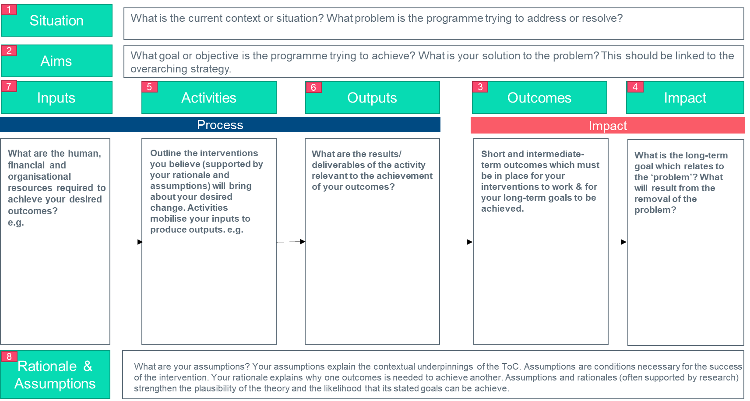

## Table 8: Project risks

Identify the top five risks to this project, how they will be mitigated, and their probability versus their impact*.* Information from this table will be assessed in relation to the extent it meets Criterion 4: value for money, project and risk management.

|  |  |  |
| --- | --- | --- |
| **Risk** | **Mitigation** | **Probability and impact** |
|  |  |  |
|  |  |  |
|  |  |  |
|  |  |  |
|  |  |  |

1. Uni Connect partnerships must use this innovation funding separately from Uni Connect funding. Innovation funding must be used for new, additional projects distinct from the delivery of the Uni Connect programme as defined in the programme guidance and operating plans.
2. The Centre for Transforming Student Access and Outcomes (TASO) 2022, Theory of Change, [www.taso.org](https://gbr01.safelinks.protection.outlook.com/?url=http%3A%2F%2Fwww.taso.org%2F&data=05%7C02%7CHeather.Bowyer%40officeforstudents.org.uk%7C4eff1cd979a04760611a08dcbacde022%7Ca9104e9942c84159b32ffab0cbee45a7%7C0%7C0%7C638590640608288975%7CUnknown%7CTWFpbGZsb3d8eyJWIjoiMC4wLjAwMDAiLCJQIjoiV2luMzIiLCJBTiI6Ik1haWwiLCJXVCI6Mn0%3D%7C0%7C%7C%7C&sdata=JgrcAIuOAmd53HK7CYavvL2HuhA2N34GdKqwDGUaOOY%3D&reserved=0). TASO’s theory of change and other useful materials can be found [at](https://gbr01.safelinks.protection.outlook.com/?url=https%3A%2F%2Ftaso.org.uk%2Fevidence%2Fevaluation-guidance-resources%2Ftoc%2F&data=05%7C02%7CHeather.Bowyer%40officeforstudents.org.uk%7C4eff1cd979a04760611a08dcbacde022%7Ca9104e9942c84159b32ffab0cbee45a7%7C0%7C0%7C638590640608303429%7CUnknown%7CTWFpbGZsb3d8eyJWIjoiMC4wLjAwMDAiLCJQIjoiV2luMzIiLCJBTiI6Ik1haWwiLCJXVCI6Mn0%3D%7C0%7C%7C%7C&sdata=cztgkEPaf0N822Unrb%2BCLHisSsM%2BCSEOtKNY1%2BQTajA%3D&reserved=0) <https://taso.org.uk/evidence/evaluation-guidance-resources/toc/>. These can be used in line with the Creative Commons Non-Commercial License: [https://creativecommons.org/licenses/by-nc/4.0/](https://gbr01.safelinks.protection.outlook.com/?url=https%3A%2F%2Fcreativecommons.org%2Flicenses%2Fby-nc%2F4.0%2F&data=05%7C02%7CHeather.Bowyer%40officeforstudents.org.uk%7C4eff1cd979a04760611a08dcbacde022%7Ca9104e9942c84159b32ffab0cbee45a7%7C0%7C0%7C638590640608311561%7CUnknown%7CTWFpbGZsb3d8eyJWIjoiMC4wLjAwMDAiLCJQIjoiV2luMzIiLCJBTiI6Ik1haWwiLCJXVCI6Mn0%3D%7C0%7C%7C%7C&sdata=K%2BsucP5%2BNWv3ro72KAw94j5IxcDSoezWX4uTFtdHuZ0%3D&reserved=0).